(3 marks) You have main function which is saved on folder named Q1 already. Use these classes and functions to test all your operations in this question, DO NOT EDIT ANY CODE in main function. You can add more operations/classes/interfaces to be able to answer the below question.

Design and code a class named Motor that holds information about a Motor. Information of a Motor includes:
- A string describes the brand name of a Motor.
- A double value describes price of a Motor.
Include the following member functions in your design:
- Constructors to set values for instance variables.
- Add needed operations to the class.
Design and code a deriving class named VNMotor from Motor class that holds information about a VNMotor. Information of a VNMotor includes:
- A String describes the series of a VNMotor.
Include the following member functions in your design:
- Constructors to set values for instance variables.
- Add needed operations to the class so that the main function can be run and complete the below method which is declared in VNMotor class, the function will be used in second test case.
  - double getSalePrice() – use to determine sale price of a Motor, sale price = original price – discount, where:
    - discount = 5 percent out of original price if original price < 3000.
    - otherwise discount = 10 percent out of original price.
Do not format the format the result.
The program output might look something like:

No of test case | Correct output | Correct output
2 | 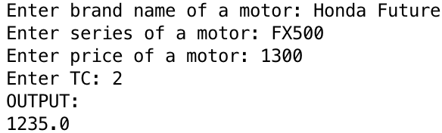 | 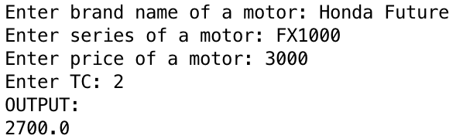
1 | 